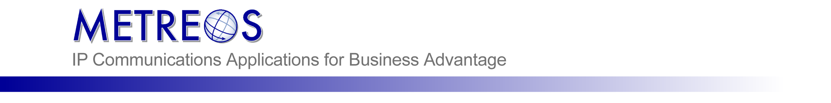
Metreos ClickToTalk Administrator Guide

Metreos Communication Environment 2.2

⎯⎯⎯⎯⎯⎯⎯
Document: Metreos ClickToTalk Administrator Guide
Part Number: CTT-AG-22004
Revision: 05/2006

Information in this document is subject to change without notice.

Copyright © 2006 Metreos Corporation. All rights reserved. Metreos trademarks marked with ® or © herein are registered or protected trademarks of Metreos in the U.S. and foreign countries. All other trademarks in the document are the property of their respective owners.

Metreos Corporation
4401 Westgate Blvd.
Suite #308
Austin, TX 78745
+1 (512) 687-2000
http://www.metreos.com

⎯⎯⎯⎯⎯⎯⎯
Contents

About This Guide 1

Intended Audience 1

Notational Conventions 1

Typographical Conventions 2

Overview 3

Installing the ClickToTalk Application 4

Configuring MCEAdmin for ClickToTalk 5

Required Settings 6

Optional Settings 9

Configuring AppSuiteAdmin for ClickToTalk 10

Configuring CallManager for ClickToTalk 10

Install and Configure ClickToTalk Outlook Plug-in 11

Using ClickToTalk 14

Making A Call 14

Recording Your Call 14

Conferencing 14

About This Guide
This guide will describe the steps to install, configure, and use the Metreos ClickToTalk application.

Intended Audience
The intended audience of this guide is the administrator of the system.

Notational Conventions
The following section summarizes the general notational conventions used in the Metreos ClickToTalk Administrator Guide.
Table 1. Notational Conventions
Convention | Description
➔ | NOTE: A note provides important information, helpful suggestions, or reference material.
 | CAUTION: A caution indicates a potential risk for damage to hardware or loss of data, and describes how to avoid the problem.

Typographical Conventions
The following typographical components are used for defining special terms and command syntax:
Table 2. Typographical Conventions
Convention | Description
Bold typeface | Represents literal information such as  - Information and controls displayed on screen, including menu options, windows dialogs and field names  - Commands, file names, and directories
Italic typeface | Italics typeface is used to denote  - A new concept  - A reference to a chapter or section heading
Courier typeface | Denotes text that is to be entered on a command line or the output of a command line program.
UPPERCASE | Denotes keys and keystroke combinations such as CTRL+ALT+DEL.

Overview
Metreos ClickToTalk™ is a speed dialing application permitting the calling of any party or parties in a contact list with a single click. ClickToTalk can be used by anyone in a Cisco CallManager group using a Cisco 7940, 7960, or 7970 IP telephone.
ClickToTalk allows you to select parties to call from your contact list, click a button on the email client user interface, and your IP telephone will dial the selected contact. Calls placed through Metreos ClickToTalk may be recorded, and may include multiparty conference calls.
Integration with Cisco IP Phone Services enables display of called party state on the phone itself. For example, if an invited conferee did not answer, a message so indicating is displayed on your phone. Also included is a robust XML-over-HTTP API, permitting easy integration into other applications such as instant messaging.
Metreos ClickToTalk ships with a plug-in for Microsoft Outlook. Other such plug-ins may easily be developed by your staff or integrator to permit calls from any HTTP-capable endpoint.
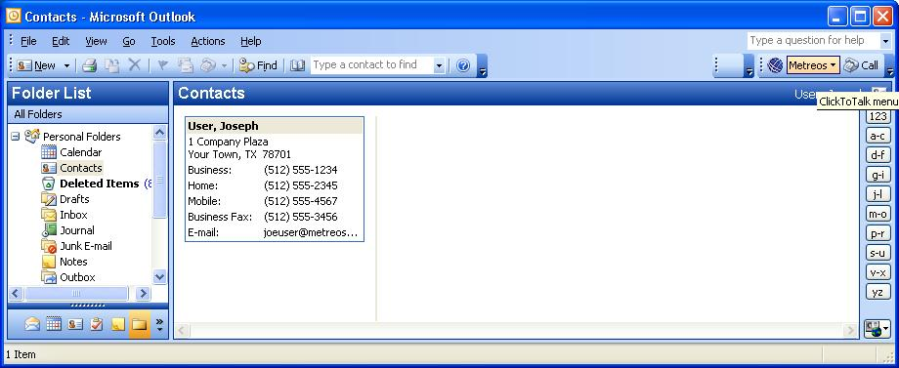
Figure 1. ClickToTalk presence on Outlook Toolbar

Installing the ClickToTalk Application
The following procedure can be used to install the ClickToTalk Application:
Procedure
- Launch and login to the Metreos Management Console at
http://<servername or IPaddress>/mceadmin.
- Click the Applications Link at the top-right under Components.
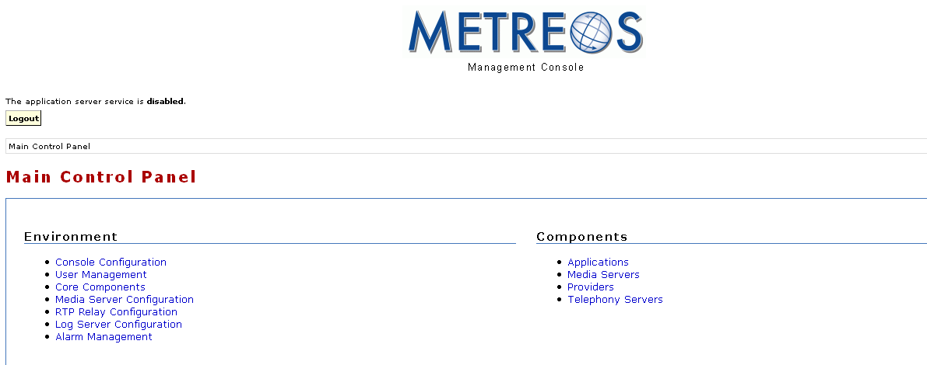
Figure 2. Applications Link on Main Control Panel Page
- Click on Browse button under Install An Application, and browse to the location of the ClickToTalk.mca file. Then click Upload File.
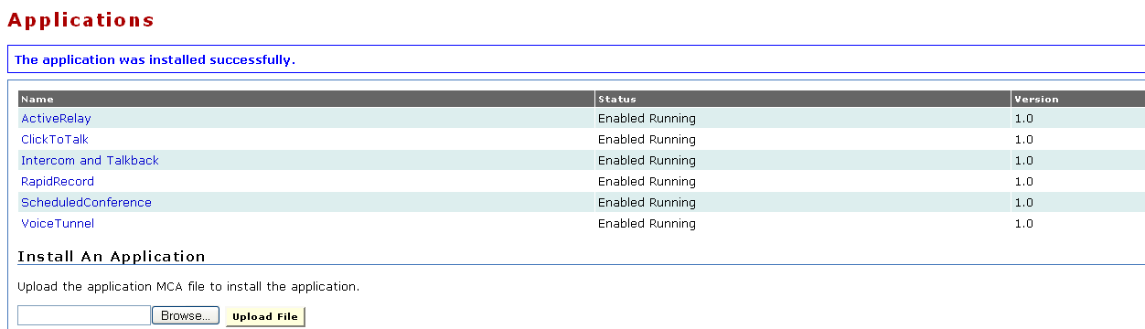
Figure 3. Installing an Application

Configuring MCEAdmin for ClickToTalk
Once the application is installed, the global application settings must be configured. Many of the default settings will be acceptable, but some additional information will need to be specified. After the options have been configured, click Apply at the top or on the bottom of the first section to save the settings.
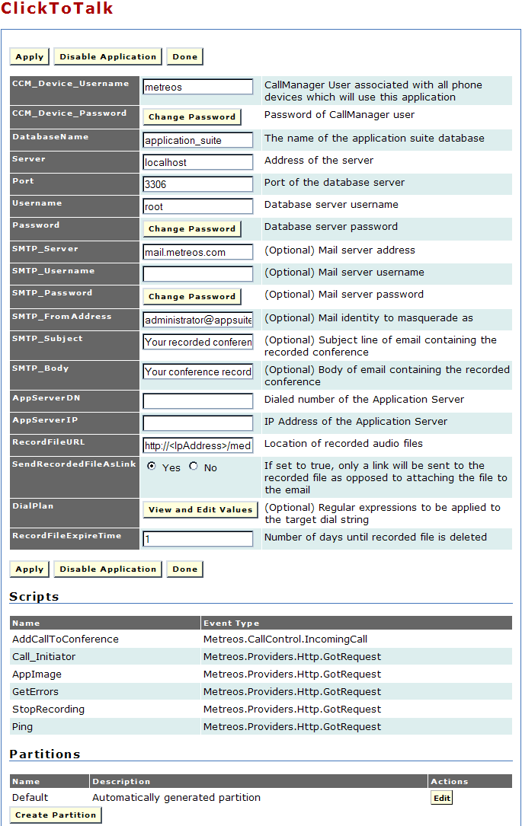
Figure 4. ClickToTalk Global Configuration Settings

Required Settings
When the application is first installed, many of the settings are already configured for you with default information that is common to most deployments.
The following fields are required, but they already have default settings defined:
  - CCM_Device_Username — Enter the Cisco CallManager username associated with phones that use Metreos ClickToTalk. (Default: metreos)
  - CCM_Device_Password — Click the Change Password button to change the password used to connect to the database. You will be prompted for your current password, the new password, and to verify the new password. After you have done so, click the Update button. (Default: metreos)
  - DatabaseName — Enter the name of the Metreos Application Suite database. (Default: application_suite)
  - Server — Enter the application server address. (Default: localhost)
  - Port — Enter the database port number. (Default: 3306)
  - Username — Enter the username used to connect to the database.
(Default: Root)
  - Password — Click the Change Password button to change the password used to connect to the database. You will be prompted for your current password, the new password, and to verify the new password. After you have done so, click the Update button. (Default: metreos)
The following fields are also required, but must be configured manually for your deployment.
  - AppServerDN — Enter the to value of the trigger parameter for Metreos ClickToTalk. This will also be the same value entered for the application trigger parameter discussed in the next section.
  - AppServerIP — Enter the IP address of the Metreos Application Server.
  - RecordFileURL — Enter the URL for the recorded messages file location.
  - SendRecordedFileAsLink — Click the Yes radio button if recordings are to be sent as links. Click the No radio button if recordings are to be sent as e-mail attachments.
  - RecordFileExpireTime - Enter the interval in days you want to keep call recordings before expiration.
Application Trigger Parameters
Just like all other applications in the Metreos Application Suite, ClickToTalk has a set of triggering parameters to start the application’s scripts on certain events. In cases where an application is divided into multiple partitions, each partition will have their own configurable settings, including triggering parameters. These parameters can be accessed through the application’s configuration page and editing the particular partition in question.
The following procedure describes how to set the trigger value for ClickToTalk using the automatically generated default partition.
Procedure
- Click the Edit button under the Partitions section at the bottom of the application’s configuration page to access settings that will be specific to that partition. In most cases, these will be the same as the global application setting previously discussed.
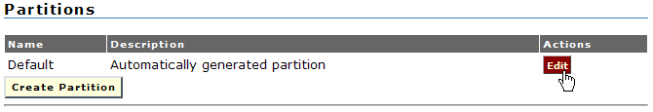
Figure 5. Edit Partitions
- Under the Scripts section, click Edit Trigger Parameters next to the script named AddCallToConference and that has the type IncomingCall.
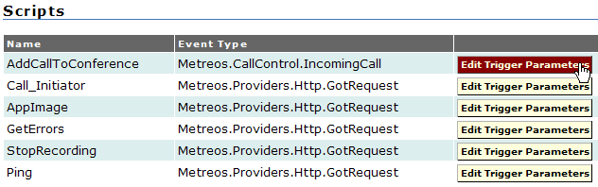
Figure 6. Edit Trigger Parameters For Script Type IncomingCall
- Under the Add Trigger Parameter section, type ‘to’ in the Parameter Name field. (Do not include the quotation marks.)
In the Initial Value field, enter the extension number that was previously specified in the global application setting AppServerDN. Click Add Parameter.
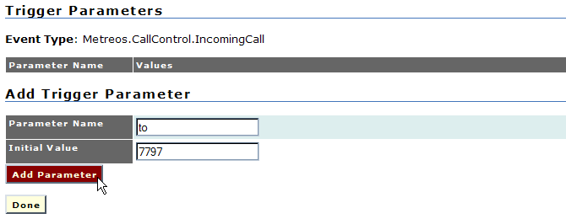
Figure 7. Adding A 'to' Trigger Parameter
- On the following screen, click Apply Parameter Values.
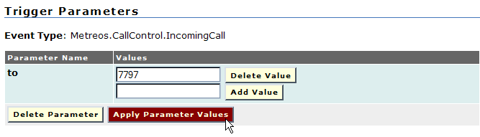
Figure 8. Applying Trigger Parameter Values
- Finally, click Done.
NOTE: In this example, the trigger event is Metreos.CallControl.IncomingCall, which occurs when the system receives an incoming call. On receipt of this event, the application runtime seeks a match between the extension in the trigger parameter and the extension of the incoming call. If a match is found, the script, in this case IncomingCall, is executed.
➔

Optional Settings
There are also some setting fields marked as optional. These settings are for enabling ClickToTalk to send email and to dial numbers external to the local phone system.
SMTP Settings
In order for ClickToTalk to email recorded conferences, a mail server must be configured. By default, mail.metreos.com is specified as the SMTP_Server, but this should be changed to the SMTP server you would like to use at your location. If these SMTP settings are not configured, ClickToTalk will be unable to email the recorded files.
  - SMTP_Server — Enter the email server address used to send recorded calls.
  - SMTP_Username — Enter the username used for access to the mail server designated above.
  - SMTP_Password — Click the Change Password button to change the password used to connect to the database. You will be prompted for your current password, the new password and to verify the new password. After you have done so, click the Update button.
  - SMTP_FromAddress — E-mail address used to identify the sender of forwarded call recordings.
  - SMTP_Subject — Enter the subject line of the e-mail message used to send recorded calls.
  - SMTP_Body — Enter the information you want to include in the body of the e-mail message used to send recorded calls.
DialPlan
ClickToTalk supports external calls. The DialPlan section allows you to define the way ClickToTalk will make calls external to the phone system. Many phone systems require pre-pending a digit, or series of digits, to the fully qualified phone number to make external phone calls. For example: 9 + 15126872000.
The DialPlan parameter uses a key/value pair in the form of a regular expression to add the preceding digit. For more information about regular expressions, please refer to http://msdn.microsoft.com/library/default.asp?url=/library/enus/
cpgenref/html/cpconRegularExpressionsLanguageElements.asp
If the dial plan is configured to require a leading 9 for external calls, use the following regular expression:
Key: ^(?<extNum>[0-9\*#]{7,99})$
Value: 9${extNum}
If the dial plan requires a digit other than 9, replace the 9 in the Value field with the required digit.
To configure the external call digit for ClickToTalk:
Procedure
- Click the View and Edit Values button.
- Enter the Key expression in the Key field, and enter the Value expression in the Value field as shown below:
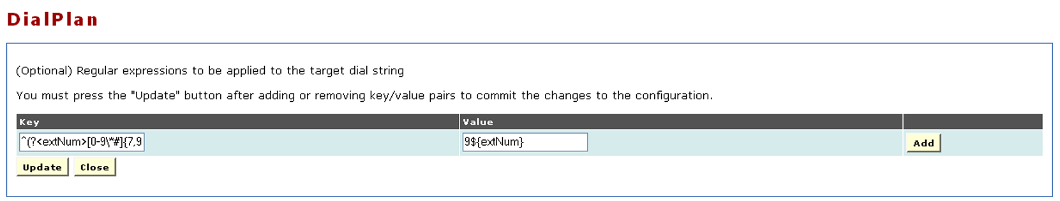
Figure 9. Example DialPlan Translations Key/Value Pair
- Click the Add button.
- Click the Update button.

Configuring AppSuiteAdmin for ClickToTalk
In order for the application to know which IP phone belongs with which user, there must be an AppSuiteAdmin user account with an associated device name corresponding to the user’s IP phone.
To do this, sign into AppSuiteAdmin (http://<servername or IPaddress>/appsuiteadmin) and then create a new user in the Account Management section. In the user’s settings, be sure to add a device, check the IP phone checkbox to specify that it is an IP phone, and enter the MAC address or Device name in the Device Name blank.

Configuring CallManager for ClickToTalk
The IP Phone device must be associated with a user in Cisco CallManager in order to push XML commands to it. Please associate any devices that will be making calls through ClickToTalk with the ‘metreos’ user in the CallManager Global Directory.

Install and Configure ClickToTalk Outlook Plug-in
The ClickToTalk Outlook Plug-in integrates with Microsoft Outlook as a custom toolbar that provides a method to call selected contacts from the contact list with the push of a button on the toolbar.
Before you begin to install (or uninstall) ClickToTalk, you should be sure to close Microsoft Outlook and Word. Do this by navigating to File then click Exit.
NOTE: Clicking the X in the top-right corner of Outlook does not always completely close the application; sometimes it will remain running in memory. To further verify that Outlook is not still running in memory, open the Task Manager and confirm that OUTLOOK.EXE and WINWORD.EXE are not present in the list.
➔
Now that Outlook and Word have been closed, you are ready to install the ClickToTalk Outlook plug-in. The executable installation file will start with the name ‘C2T-Outlook-Plugin’ and it will contain the version number. When you have located the executable corresponding to the MCE version that is running on the appliance, double-click on this file to begin installation. Follow the on-screen instructions provided through the installation wizard, accepting all defaults.
Once installation is complete, start Microsoft Outlook and the ClickToTalk button will be found on the Outlook toolbar.
NOTE: When updating to a later version of the ClickToTalk outlook Plug-in, you should first uninstall any existing ClickToTalk Plug-in, by navigating to the Windows Start menu, Control Panel, Add or Remove Programs, and from there select the Metreos ClickToTalk plug-in for uninstallation.
➔
Before using the ClickToTalk Outlook Plug-in for the first time, you must configure it with the information required to log you into the Metreos Application Suite server. This information will be saved in the registry, and as such, need be configured only after installation of ClickToTalk, or in the event that your logon information changes.
Clicking on the ClickToTalk button on the Outlook toolbar, pops-up a menu containing the single entry Settings. Selecting this menu item pops up a Metreos ClickToTalk Settings dialog as shown below.
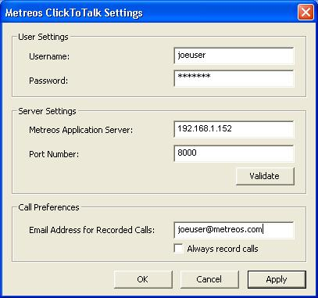
Figure 10. Metreos ClickToTalk Settings
  - Username/Password — Enter your Metreos Application Suite user name and password. This was the account created when configuring AppSuiteAdmin for ClickToTalk.
  - Metreos Application Server/Port Number — Enter the Metreos Application Suite IP address, and port number.
  - Email Address for Recorded Calls/Always record calls — Enter the email address to which you wish to have sent any call recordings you might request. If you wish to record all calls you initiate, check the box labeled always record calls.
After entering information into the Metreos ClickToTalk Settings dialog, see Figure 10, press the button in the middle labeled Validate, to ensure connectivity to the Metreos Application Suite runtime environment can be established. A progress bar will be displayed, and you will be presented with a message indicating either that a connection was established, or the connection attempt failed. If successful, this one-time setup is complete, and Metreos ClickToTalk is ready to dial your calls with one click.
If, however, connectivity could not be established, ensure that:
  - The Metreos runtime environment is active.
  - You have entered the correct IP address and port number for the Metreos Application Server, into the Metreos ClickToTalk Settings dialog.
  - Your Metreos Application Suite user account has a password associated with it.
  - You have entered into the Metreos ClickToTalk Settings dialog the correct account name and password for your Metreos Application Suite user account.

Using ClickToTalk
Once ClickToTalk has been installed and configured properly, it is available for use.

Making A Call
To make a call, simply select an entry in your contact list, and click the Call button on the Metreos ClickToTalk Outlook toolbar. The contact telephone number will be displayed to you at this time, which you can modify if you wish. Your IP phone will dial the selected party, so simply pick up the handset and talk.
NOTE: There is a ‘dial’ button on the Outlook standard toolbar that looks similar to the Metreos ‘Call’ button. This button does not initiate Metreos ClickToTalk. Be sure to use the buttons on the Metreos toolbar to leverage the Metreos ClickToTalk features.
➔

Recording Your Call
At the time you click to talk, a dialog is displayed with the contact telephone number, as described above. To record the call, check the box labeled Record this call, found on this dialog. Of course, if in your ClickToTalk Settings, described earlier, you had specified that all calls were to be recorded, you need not specify that again here. To stop recording the call at any time, press the button labeled Stop Recording, also found on this dialog.

Conferencing
To begin a conference call, simply select multiple (up to four) entries from your contact list and click to talk. Should any party fail to answer, a message so indicating will appear on your phone display. Recording of your conference call is accomplished similarly to recording of a single party call as described above.

